Victory at Sea Matched Play V 0.1

# Matched Play Games

For playing a matched game of Victory at Sea follow the sequence below:

1. Select Size
   * The players must first select the battle size they wish to play

|  |  |
| --- | --- |
| **Battle Size** | **Points** |
| Battle Group | 1000 |
| Task Force | 2000 |

1. Select Year
   * The players must select what year is to be used for the game from the following
     + 1939
     + 1940
     + 1941
     + 1942
     + 1943
     + 1944
     + 1945
     + 1946+
     + All Ships
   * The Year effects what ships can be selected when selecting fleets.
2. Select Fleets
   * Each player must then select a fleet using the rules below. The point limit of each player’s fleet is shown in the table above for the game size chosen.
3. Determine Mission
   * The player determine the mission that will be used for the battle which can either be chosen by both the players from the table of missions for their battle size or by rolling a d10 and taking the corresponding mission from the table.

|  |  |
| --- | --- |
| Result | Mission |
| 1-2 | Mission 1 |
| 3-4 | Mission 2 |
| 5-6 | Mission 3 |
| 7-8 | Mission 4 |
| 9-10 | Mission 5 |

1. Read Mission Briefing
   * Each mission has a briefing which details the primary objectives being used as well as any other information that is needed to play that mission.
2. Place Objectives
   * The players now set up a number objectives on the table as shown in the mission briefing for the mission.
3. Create The Battlespace
   * The players now create the battlespace and set up terrain features. The missions are played on a 6’ by 4’ rectangular space. When setting up terrain features such as island they shouldn’t be placed within 6” of any objective markers.
4. Select Secondary Objectives
   * Each player secretly selects 2 secondary objectives and notes them down. These secondary objectives give another way for the players to score victory points. The list of secondary objectives is found below for players to choose from as well as some missions having an option for a secondary objective. Once both players have selected their secondary objectives, they reveal these to their opponent.
5. Choose deployment zones
   * The players roll off, with the winner getting to choose which deployment zone they use for their fleet with their opponent using the other deployment zone.
6. Select Scouts
   * Both players secretly note down any destroyers or cruisers from their fleets they wish to assign to scouting along with the number of observation flights to be assigned to scouting. Once both players have decided which cruisers, destroyers and observation flights to assign to scout, the players reveal this information to their opponent.
7. Deploy Fleets
   * The players roll off and the player who scores lowest must deploy their entire fleet, except any ships assigned to scouting, within their deployment zone. Once they have finished their opponent deploys their entire fleet, except for any ships assigned to scouting, within their deployment zone.
8. Roll Scouting Dice
   * Both players roll a d6 for each destroyer, cruiser and observation flight assigned to scouting. Each dice that rolls a 5+ earns that player a single scouting point. When all dice have been rolled both players should compare their total scouting points with the scouting table.
9. Resolve Scouting Table Actions
   * Starting with the player with the least scouting points, may resolve any action allowed by their scouting point total such as redeploying. If the players have the same number of scouting points the players roll off and the losing player resolves their scouting table actions first.
10. Begin the Battle
    * The first game turn begins. Players continue to resolve the game turns until the battle ends.
11. Ending the Battle
    * The Battle lasts 8 game turns. If one player has no ships remaining in their fleet then the other player may continue to play out their remaining turns until battle ends.
12. Determine the Victor
    * At the end of the battle the player with the most victory points is the winner. If both players have the same victory points totals then the game is a draw.

# Fleet Selection

When a player selects their fleet they must choose a single fleet list (i.e The Royal Navy, The US Navy, The Marine Nationale, The Kriegsmarine, The Imperial Japanese Navy or The Regia Marine) to pick all of their ships, aircraft flights and MTB sections.

Additionally when choosing a fleet the player must ensure the following conditions are met by their fleet;

* Ships being selected must have years that are the same as for before the selected Year. If “All Ships” was selected then any ship may be selected regardless of the Commissioned year.
* Named ships may be chosen but no ship may use any refits. Named ships effectively may be taken multiple times but each ship must be given a unique name though the ship that it is copy should be noted as well. For example “HMS Resistance (Renown)” copies “HMS Renown” Renown-Class Battleship.
* If a ship class has no commissioned date next to the Commissioned date then they may only be selected when the Year is set to “All Ships” instead of a specific historical year
* Only 25% (one quarter) of the point limit may be used to add land based flights
* If any MTB sections are included then only a single ship from either the Battleship or Carrier sections may also be included in the fleet list
* Ships from the Civilian fleet list may not be taken
* If the fleet includes any carriers then each carrier must have listed what flights are being used on the fleet list

# Primary Objectives

Primary objectives very from mission to mission with each mission briefing describing how to score primary objective victory points. You can score no more than 90 points from the primary objective. Any excess victory points would be scored beyond this value are discounted.

At the end of each game turn both players score 5 points for each of the following that they achieve;

* Control one or more objective markers
* Control two or more objective markers
* Control more objective markers than their opponent controls

# Secondary Objectives

Here is the list of secondary objectives that can be chosen from when instructed to select secondary objectives. You can score no more than 15 victory points from each secondary objective. Any excess victory points that would be scored beyond this are discounted.

* Big Game Hunter
  + Score 3 points at the end of the battle for each Battleship or Carrier with 90 Hull or less, and 4 points for each battle ship or carrier with greater than 90 Hull
* Pride of the Fleet
  + If you choose this objective, before the battle starts but after the scouting table actions have been resolved, you must identify the 3 ships that have the highest points cost that aren’t in Deep Deployment. If your fleet contains less than 3 ships that aren’t in deep deployment then you identify all ships instead. If there are more than 3 ships with the highest points cost then you may choose between them, for example if there are 2 ships with the same third highest points cost you would get to select which one is identified.
  + At the end of the battle score 5 victory points for each of these ships that are on the table at the end of the battle.
  + When working out the highest points cost for ships you should include the cost of any refits taken and of the points system being used requires carriers to pay additional points for their aircraft flights that cost is counted as part of the carriers cost.
* Attrition
  + Score 4 points at the end of a game turn if more enemy ships were destroyed than friendly ships this game turn.
* Domination
  + Score 3 victory points at the end of the game turn you control at least half of the objective markers on the table
* Ultimate Enemy
  + If you choose this objective, before the battle starts, but after the scouting table actions have been resolved, your opponent must identify the ship with the highest point cost not in Deep Deployment. If their fleet contains two ships with the same points cost as the most expensive, then your opponent may select which one is identified. At the end of the battle you score 6 points if that ship was destroyed.
* Breakthrough
  + Score 3 victory points at the end of each game turn if you have at least 2 ships within the enemy normal deployment zone
* Defence Line
  + Score 2 victory points at the end of each game turn if there are no enemy ships within 6” of your normal deployment zone
* Encirclement
  + Score 1 victory point at the end of the game turn if you have at least one ship in at least 3 table quarters. If there are no enemy ships in at least 3 table quarters score an additional 2 victory points at the end of the turn.
* Last Stand
  + At the end of the game score points for the following;
    - Score 3 victory points if you have more battleships on the table than your opponent
    - Score 5 victory points if you have more carriers on the table than your opponent
    - Score 3 victory points if you have more cruisers on the table than your opponent
    - Score 3 victory points if you have more destroyers on the table than your opponent
* Air Defence Expert
  + Score 2 points at the end of the game turn if at least 3 enemy aircraft flights were destroyed this turn.
* Destroy!
  + Score 2 points at the end of the game turn if at least 2 ships were destroyed this turn

# Objective Markers

Objective Markers are a 20mm round marker. When measuring to the marker you measure to the centre of the marker.

For counting towards controlling an objective, the bridge of the ship must be within 6” of the objective. A ship can only count towards controlling a single objective marker at once. The player with the most ships within range controls the objective marker.

Aircraft and MTBs can never count towards controlling an objective marker.

# Missions

## Mission 1

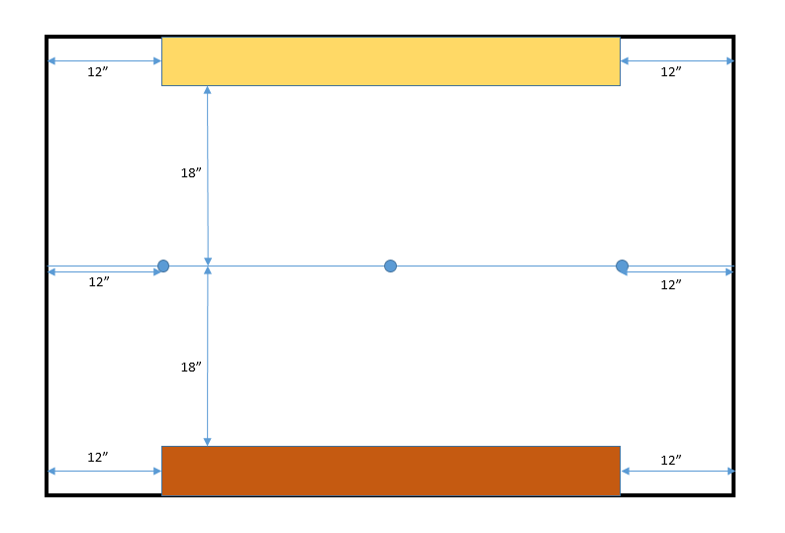

## Mission 2

## Mission 3

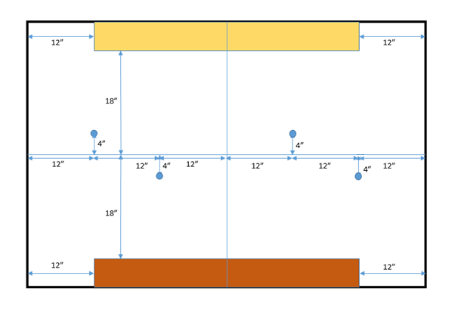

## Mission 4

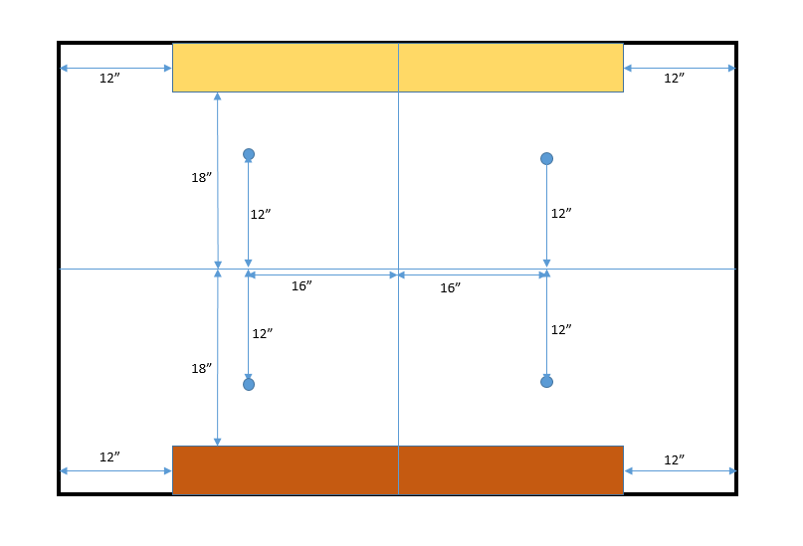

## Mission 5

